**Docker Volumes:**

* Docker volumes are directories inside a container or on host server.
* We can store the data like information about containres on volumes.Share the data b/w multiple containers by using volumes.
* We can create the volumes by using docker file or docker cli commands i.e **docker volume create volumename**
* We can attach or share the volumes to other containers while creating the containers by using below command

**docker run -it --name containername(newcontainer) --privileged=true --volumes-from containername(from which container volume we want to attach) imagename**

**Docker file to create the volume**

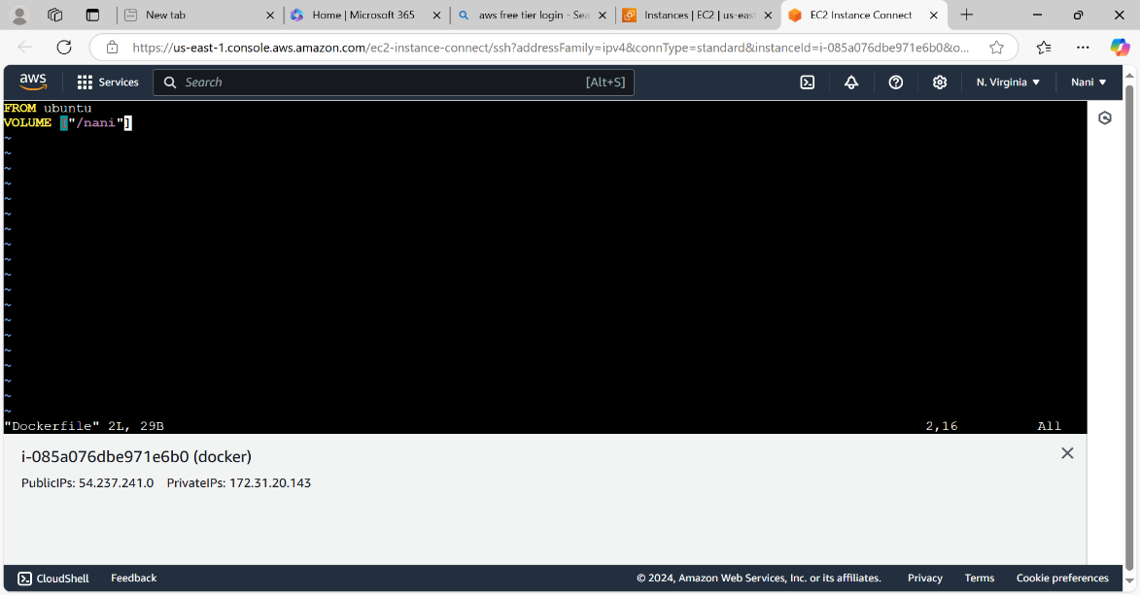

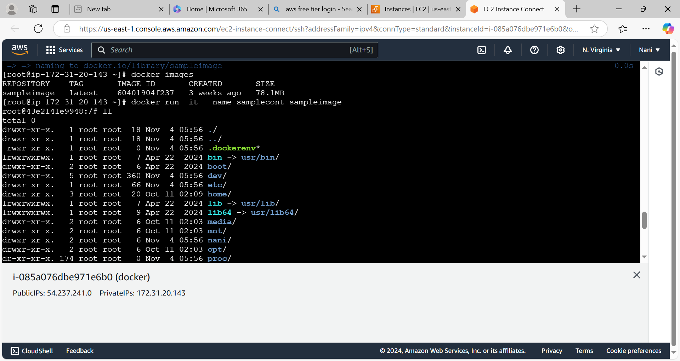

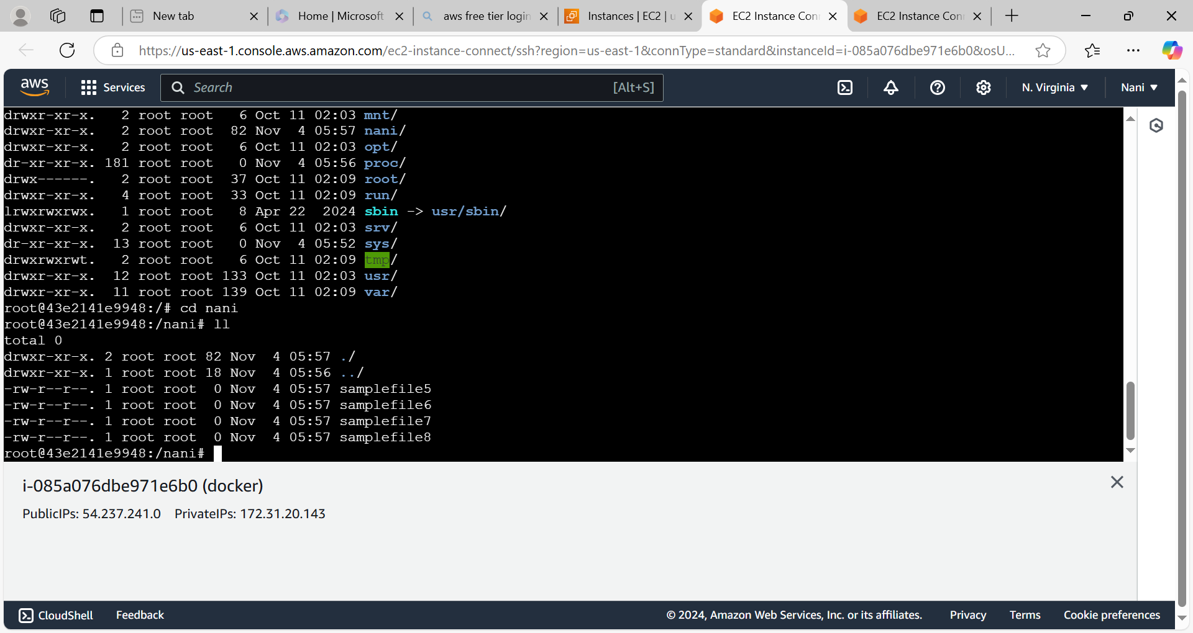

**While Creation of the new container we can attach the volume to that new container(samplecont2) from another container(samplecont).**

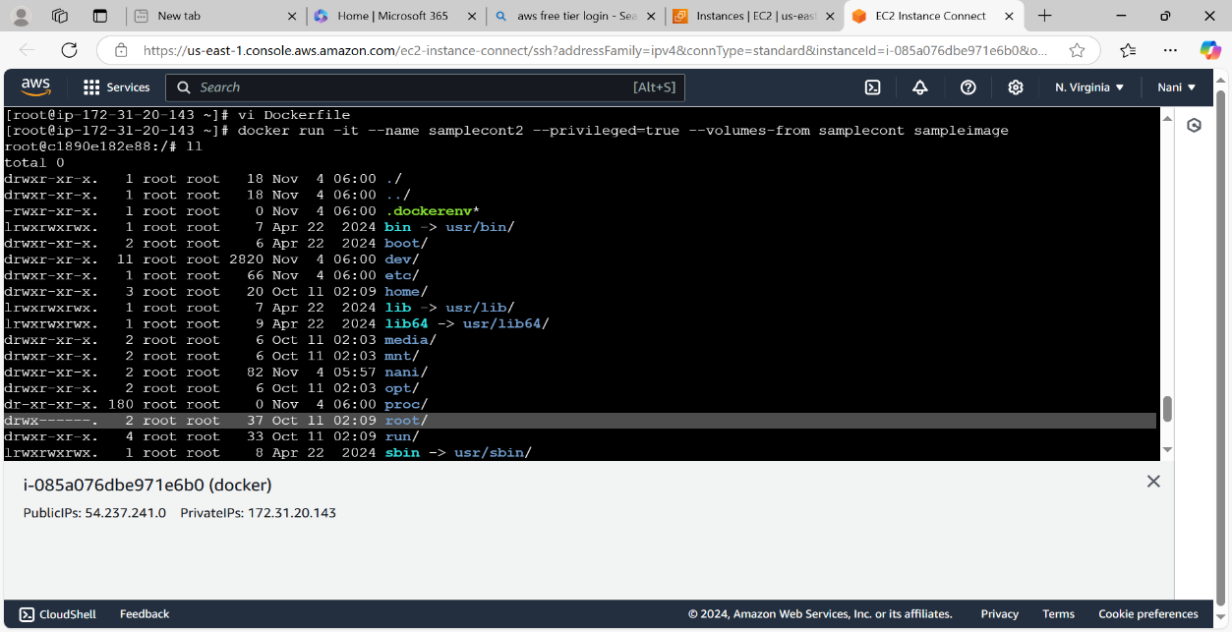

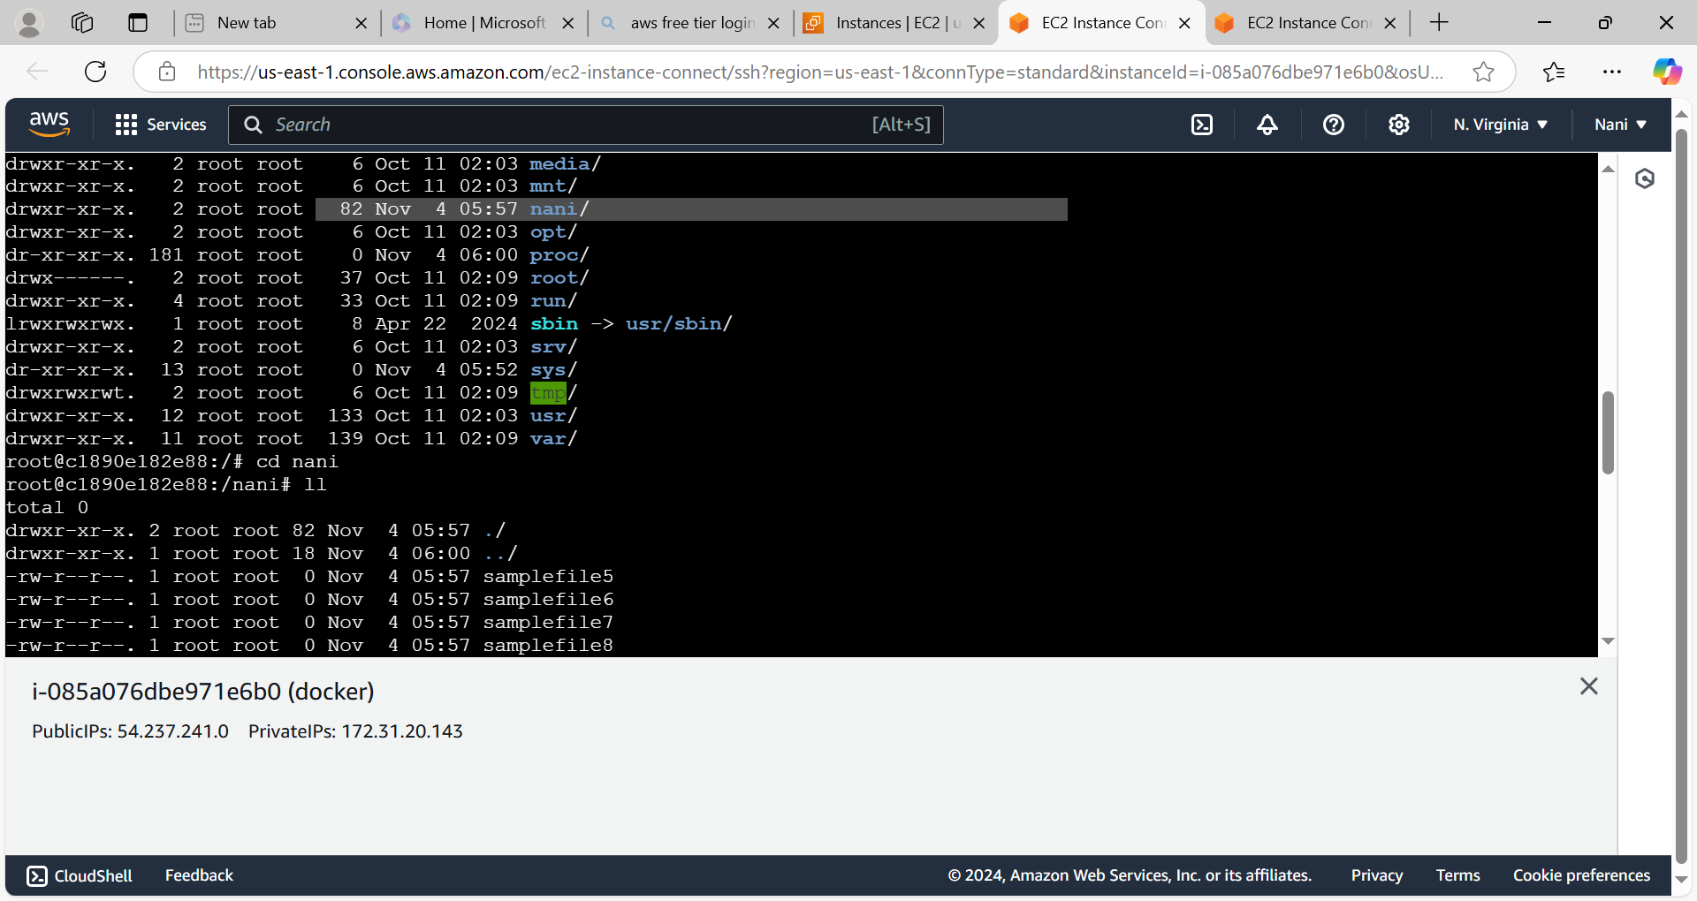

* We can also share the volume by using below command(this command is used when we create the volume on host server by using docker cli command)

**docker run -it --name containername --mount source=volumename,destination=newvolumename(we can give any name) imagename**

**Create the volume and attch it to the container**

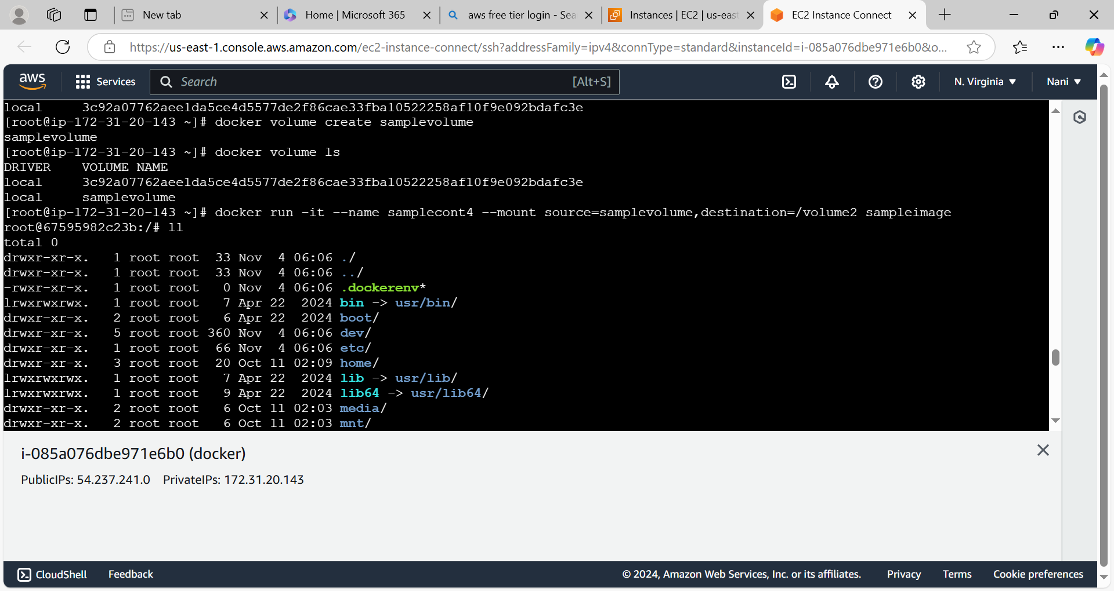

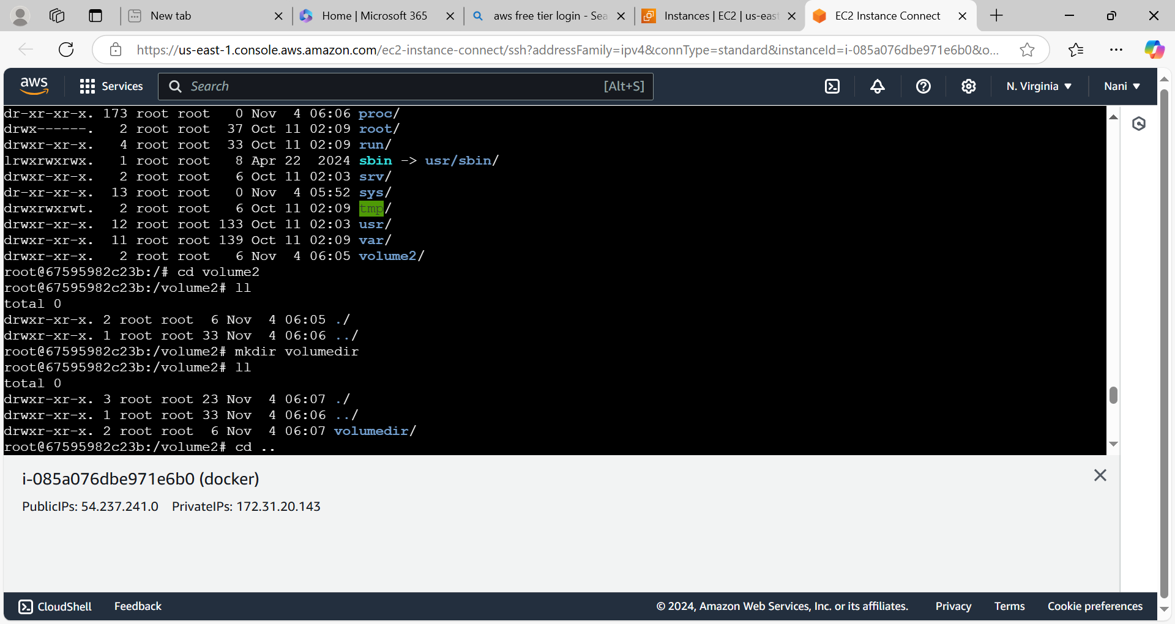

**Directory which is available on new container(samplecont4) the same directory is also available in Sample volume(whatever we have created)**

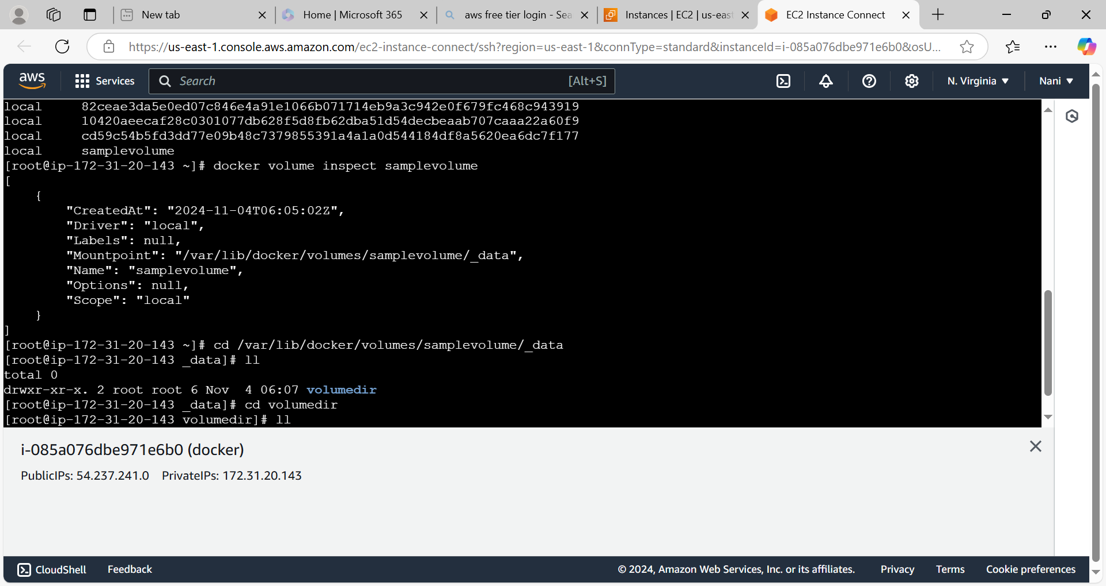

* Even if container is goes down or deleted but volume will be available or volume will not be deleted.